**PRE-LAB: WEEK 4**

**Wireshark Activity: OSI Layers**

Part 1 – Capture Setup

1. Open Wireshark from your laptop/desktop and select your active interface (Wi-Fi or Ethernet).
2. Start a capture.
3. Visit a website in your browser: **www.cisco.com**
4. Stop the capture after 30 seconds.
5. Apply the filter: **dns**

Part 2 – Packet Inspection

Select **Standard Query A for www.cisco.com** and expand the sections in the middle Wireshark pane.

Note: In DNS, “**A**” is a record type for **IPv4**, it stands for Address Record.

“**AAAA**” = is a record type for **IPv6**, it stands for Quad A Record

You should see:

1. Frame
2. Ethernet II
3. Internet Protocol Version 6 (IPv6) or IPv4 depending on your system
4. Transmission Control Protocol (TCP) or UDP
5. Domain Name System (DNS)

Part 3: Record the Wireshark Information

1. Ethernet II

OSI Layer Number: ______

OSI Layer Name: ____________________

PDU: ____________________

Information to Record:

Source MAC: ____________________

Destination MAC: ____________________

Screenshot Evidence:

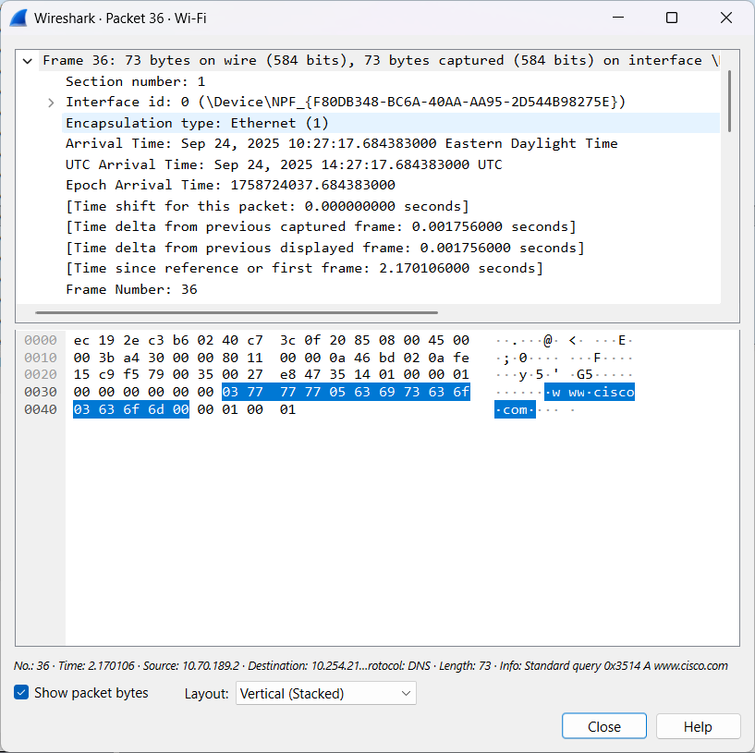2. IPv6 / IPv4

OSI Layer Number: ______

OSI Layer Name: ____________________

PDU: ____________________

Information to Record:

Source IP: ____________________

Destination IP: ____________________

Screenshot Evidence:

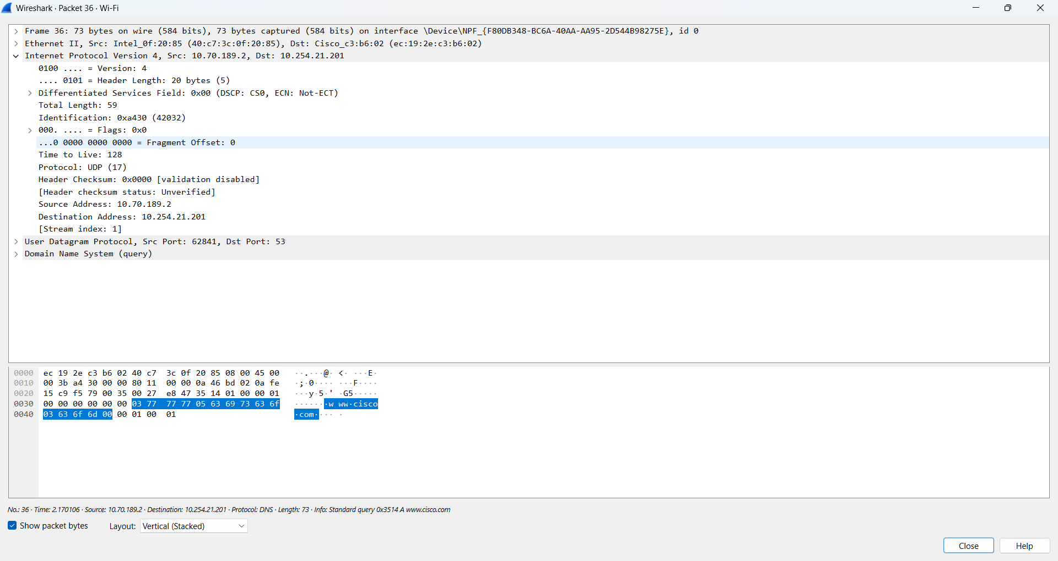

3. TCP / UDP

OSI Layer Number: ______

OSI Layer Name: ____________________

PDU: ____________________

Information to Record:

Source Port: ____________________

Destination Port: ____________________

Screenshot Evidence:

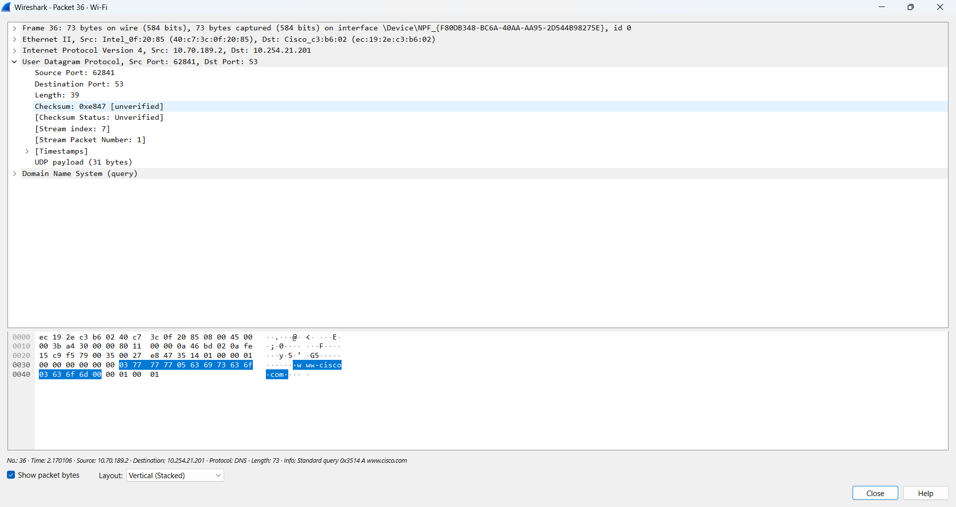

4. DNS

OSI Layer Number: ______

OSI Layer Name: ____________________

PDU: ____________________

Information to Record:

Standard Query A: www.cisco.com

Standard Query Response A cisco.com: ____________________ (IPv4 address)

Screenshot Evidence:

